RIPHAH INTERNATIONAL UNIVERSITY


Faculty of Computing
Object Oriented Programming Lab
Lab 4
Arrays, For Each Loop, Wrapper Classes and String Processing
Submitted By: Khadija Binte Asif
SAP ID: 77954
Submitted To: Miss Nayab Khalid

Lab Manual Development Team

Supervision and Coordination

Hira Jafar
Lecturer
Faculty of Computing

Lab Designers

Nayab Khalid
Teaching Fellow
Faculty of Computing

Tasks
Task 1
Write a Java program to store the marks of five students using an ArrayList<Integer>. Use an Enhanced For Loop to display all the marks, calculate and display the total and average marks, and find and display the highest mark.
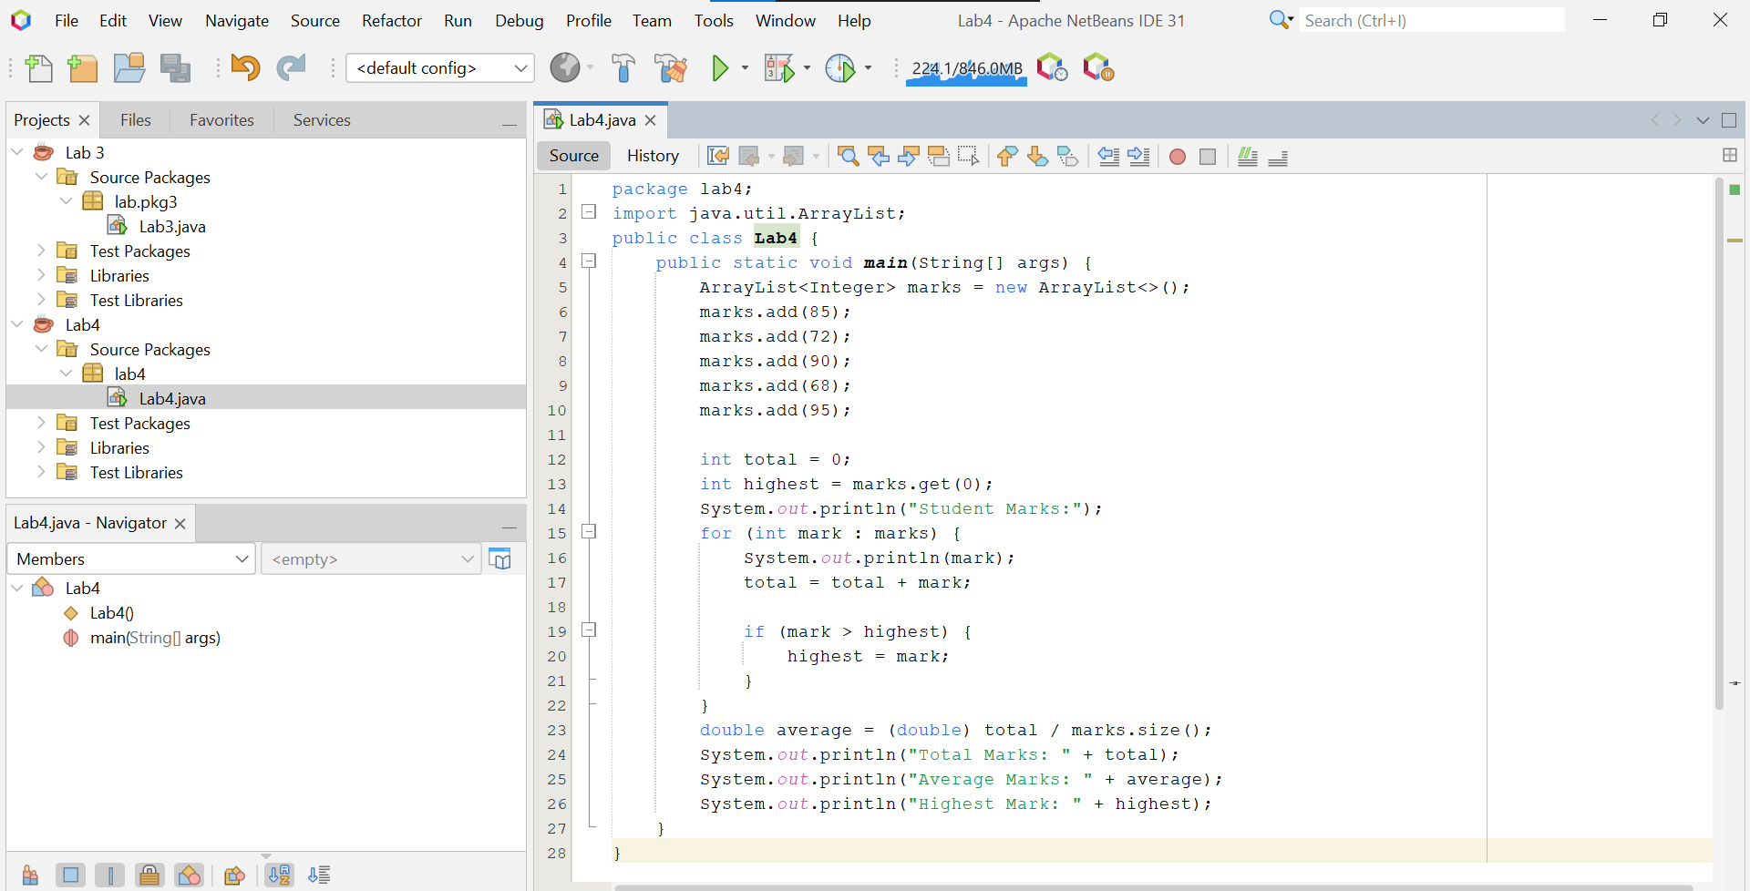

Output:

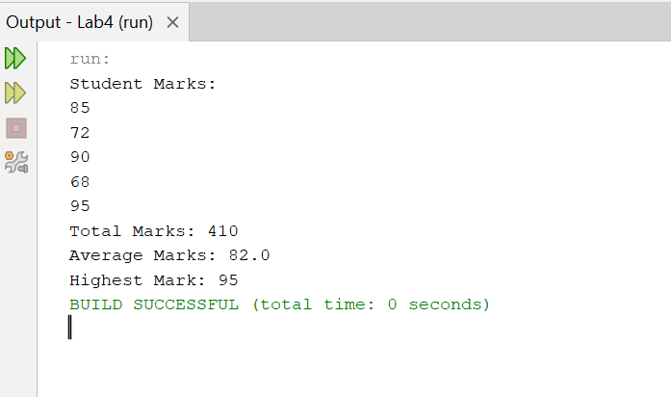

Task 2
Write a Java program that takes a student's name as a String and performs basic string processing. The program should display the original name, its uppercase and lowercase forms, the total number of characters, the first character using charAt(), and whether the name contains the letter "a".

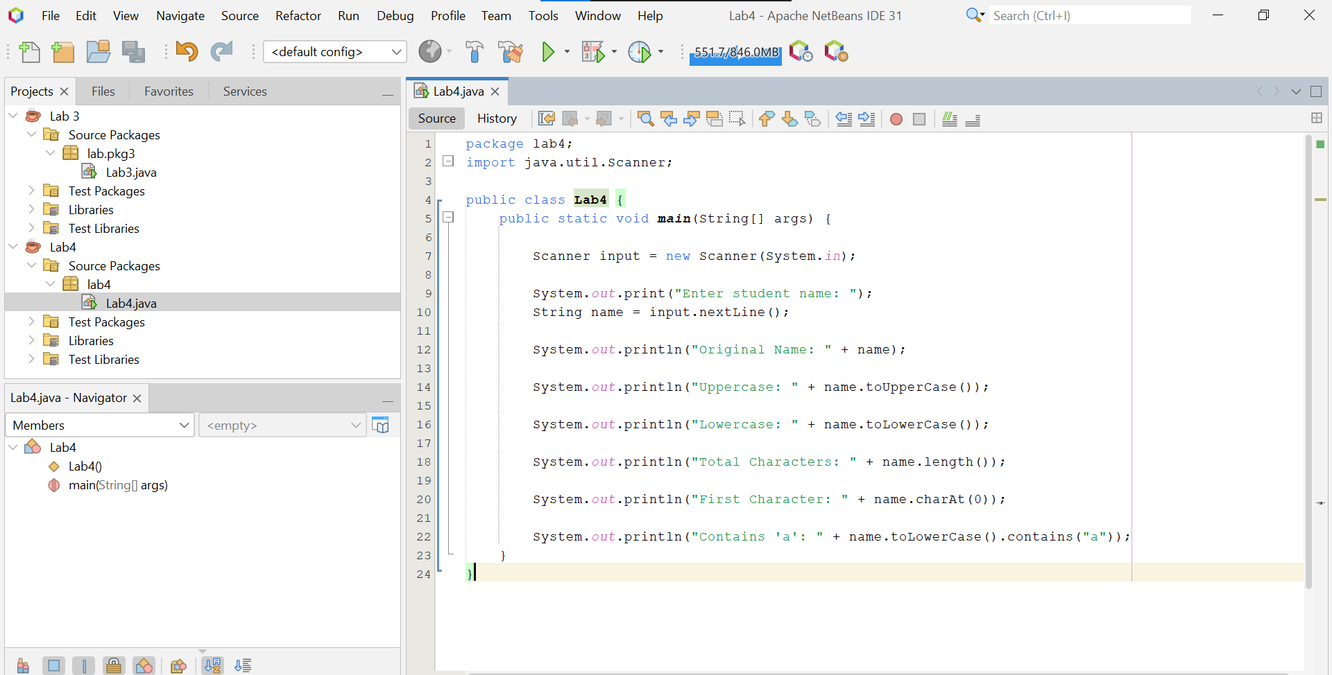

Output:
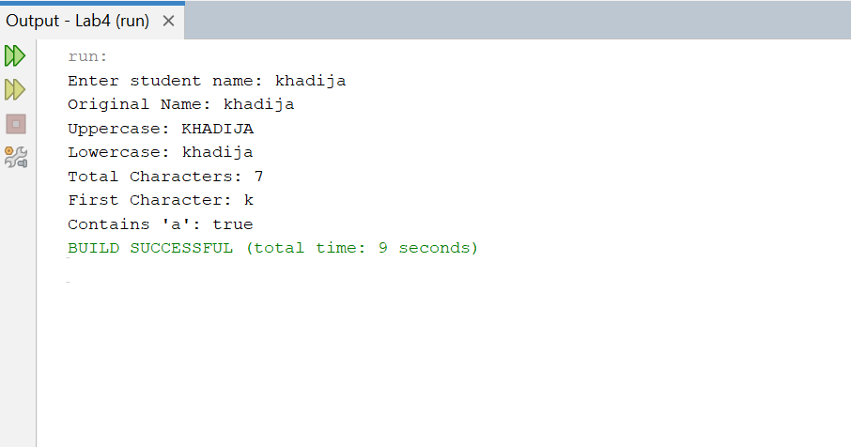

Task 3
Write a Java program that takes a single character from the user and stores it in a char variable. Display the entered character and its corresponding integer/Unicode value. The program should also determine whether the character is a digit, an uppercase letter, or a lowercase letter, and display the appropriate message.
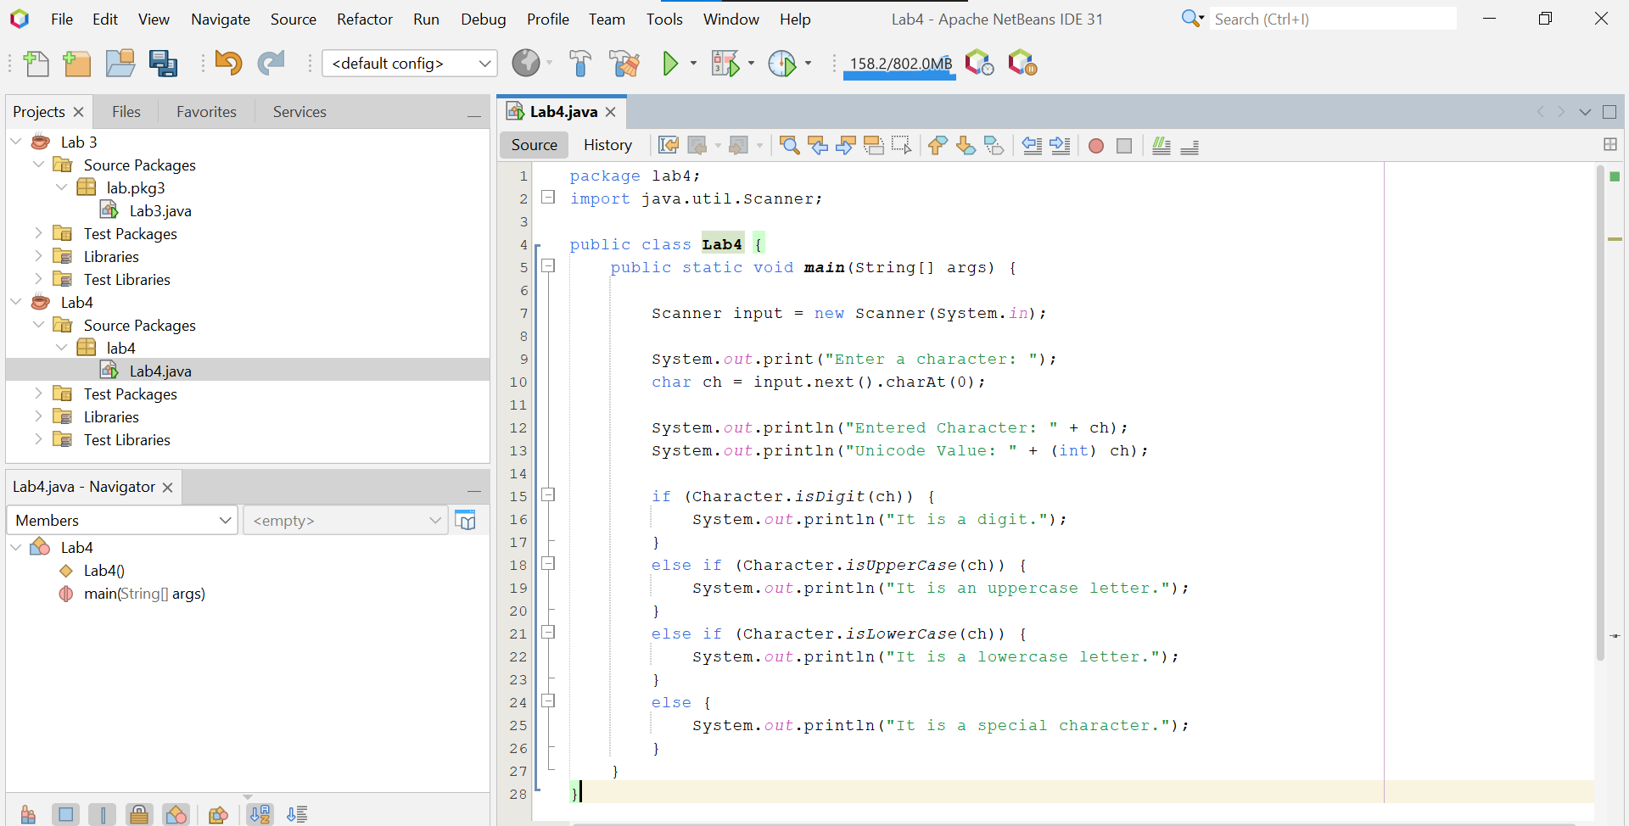

Output:


